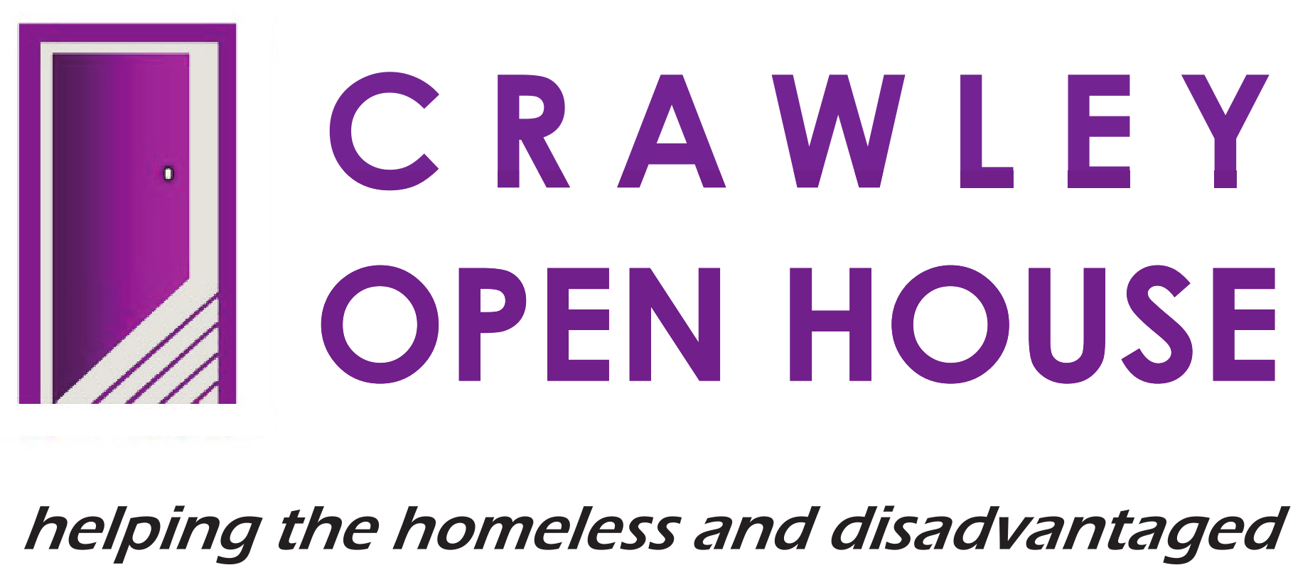 |  | JOB DESCRIPTION –  SESSIONAL WORKER,  RIVERSIDE HOUSE

POST:  RESPONSIBLE TO:  LOCATION:  HOURS:  WAGE: | Sessional Worker  Hostel Manager  Riverside House, Crawley  As available  £11.45 per hour, plus additional payments for Friday and Saturday nights as worked

JOB PURPOSE

- To provide support and guidance to vulnerable adults living in the hostel and using the day centre.

- To work as part of a multi-disciplinary team that works to help identify and meet client’s personal, social, health, learning, work and housing needs.

- To contribute to a culture of excellence that puts our core values – caring, honesty, respect and responsibility – at the centre of all we do, whilst continually improving and developing our service.

MAIN DUTIES AND RESPONSIBILITIES

- CLIENTS

- To establish positive working relationships with both colleagues and clients.

- To provide support to clients that is person-centred, in line with the individual client’s needs/wishes and with Crawley Open House’s values, policies and practices.

- To provide a clean, warm, welcoming, safe, non-discriminatory and non-judgemental environment for all clients.

- To carry out a full induction process with each new resident ensuring that all relevant paperwork is completed, e.g., key-worker allocated, appointments made with appropriate day-centre workers and health professionals, booking in forms completed, etc.

- To liaise effectively with other services/professionals/colleagues and other significant people in meeting the needs of the clients.

- To promote client involvement in the delivery of the service through listening to their issues, involving them in user meetings, accepting constructive feedback, etc.

- To issue warnings, ‘penalty points’ and evictions, as necessary, in line with current policies and procedures.

- SERVICE DELIVERY

- To assist in the development and implementation of life skills classes and workshops.

- To carry out regular health and safety inspections of the premises and to report any maintenance problems or repairs required, to a Manager.

- To provide cover for day centre staff in their absence, e.g., prepare meals in the absence of the Day Centre kitchen staff or work on the desk in the absence of the reception worker.

- To keep records and logs up to date and accurate in line with Crawley Open House policy.

- To collect and provide accurate statistics as requested by any member of the management or administration teams.

- HEALTH & SAFETY

- To ensure that you are aware of, and to comply with, Crawley Open House Health & Safety Policies.

- To ensure that all clients are aware of the procedures, especially those relating to fire or other emergencies.

- To ensure communal areas are kept clean and free of obstruction at all times and that all appropriate equipment is present and in working condition, e.g., fire extinguishers and blankets.

- To respect Crawley Open House policy with regard to smoking.

- EQUAL OPPORTUNITIES

- To ensure that Crawley Open House’s Equal Opportunities Policies are implemented and adhered to.

- To challenge and report any incidences of prejudice, discrimination, oppression or behaviour that might be construed as abusive or poor practice.

5. RELEVANT MATTERS

- To maintain confidentiality regarding clients, staff and business sensitive information in line with Crawley Open House policy and procedure.

- To undertake and participate constructively in induction, supervision, appraisal, meetings and relevant training.

- To contribute positively to good team relationships and the continuous improvement of services.

THIS JOB DESCRIPTION OUTLINES THE MAIN DUTIES AND RESPONSIBILITIES OF THE POST HOLDER. THE POST WILL INCLUDE OTHER DUTIES AND RESPONSIBILITIES NOT SPECIFIED HERE.

