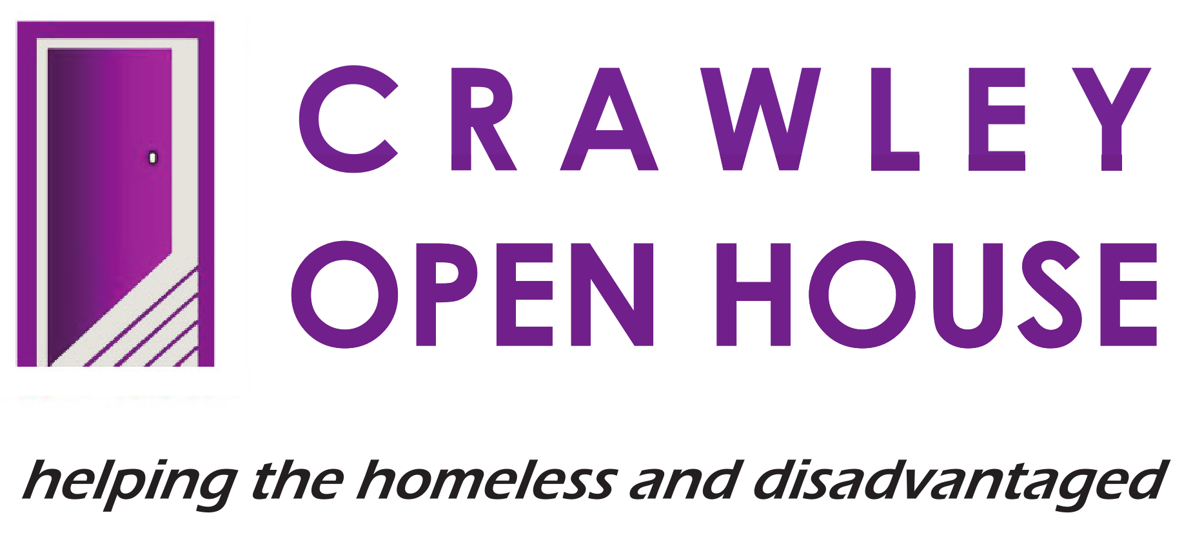 |  | JOB DESCRIPTION –  RESOURCE-CENTRE  HEALTH WORKER

POST:  RESPONSIBLE TO:  LOCATION:  HOURS:  ANNUAL LEAVE  SALARY: | Resource-Centre Health Worker  Head of Day Services  Riverside House, Crawley  Part-time – 30 hours per week.  150 hours per calendar year  £19,500

JOB PURPOSE

- To be part of the health team responsible for the provision of physical and mental health support and guidance to vulnerable adults accessing our Resource Centre drop-in

- To work as part of a team that works to help identify and meet client’s personal, social, health, work and housing needs.

- To contribute to a culture of excellence that puts our core values – caring, honesty, respect and responsibility – at the centre of all we do, whilst continually improving and developing our service.

MAIN DUTIES AND RESPONSIBILITIES

- SERVICE DELIVERY

- To take responsibility for a caseload of clients, providing appropriate and relevant health focussed guidance, advice and support related to physical health, mental health and alcohol/substance misuse issues.

- To work with individuals to identify health support needs and strengths to maximise recovery.

- To promote the recovery of clients through planned positive risk taking while minimising likely harm.

- To work pro-actively in promoting the well-being of clients, e.g., nutrition, smoking cessation, etc.

- To take a holistic approach to supporting client’s needs by providing support that is person-centred, in line with the individual client’s needs/wishes and with Crawley Open House’s values, policies and practices.

- To work to best practice national standards and ethical frameworks.

- To provide a clean, warm, welcoming, safe, non-discriminatory and non-judgemental environment for all clients.

- To support the Doctor and other health professionals with their surgeries by ensuring that clients with appointments see him/her at the appropriate times.

- To carry out a needs assessment process with each new resource centre user ensuring that all relevant paperwork is completed

- To liaise and collaborate effectively with other services/professionals/ colleagues and other agencies in meeting the needs of the clients, making referrals to other agencies as and when appropriate

- To advocate for client’s entitlements, including primary, secondary and mental health care structures and professionals, and challenging inequalities and exclusions.

- To promote client involvement in the delivery of the service through listening to their issues, involving them in user meetings, accepting constructive feedback, etc.

- ADMINISTRATION

- To keep records and logs up to date and accurate in line with Crawley Open House policy.

- To collect and provide accurate statistics as requested by any member of the management or administration teams.

- To assist the Health and Outreach Team Manager in the support and supervision of volunteers and placement staff.

- To keep up-to-date on organisations and facilities relative to Health within the Crawley area and to provide appropriate advice and support to other Open House staff.

- HEALTH & SAFETY

- To be aware of, and to comply with, Crawley Open House Health & Safety Policies.

- To make sure all clients are aware of policies and procedures, especially those relating to fire and/or other emergencies.

- To ensure communal areas are kept clean and free of obstruction at all times and that all appropriate equipment is present and in working condition, e.g., fire extinguishers and blankets.

- To respect Crawley Open House policy with regard to smoking.

- EQUAL OPPORTUNITIES

- To ensure that Crawley Open House’s Equal Opportunities Policies are implemented and adhered to.

- To challenge and report any incidences of prejudice, discrimination, oppression or behaviour that might be construed as abusive or poor practice.

- RELEVANT MATTERS

- To maintain confidentiality regarding clients, staff and business sensitive information in line with Crawley Open House policy and procedure.

- To undertake and participate constructively in induction, supervision, appraisal, meetings and relevant training.

- To contribute positively to good team relationships and the continuous improvement of services.

THIS JOB DESCRIPTION OUTLINES THE MAIN DUTIES AND RESPONSIBILITIES OF THE POST HOLDER. THE POST WILL INCLUDE OTHER DUTIES AND RESPONSIBILITIES NOT SPECIFIED HERE.

