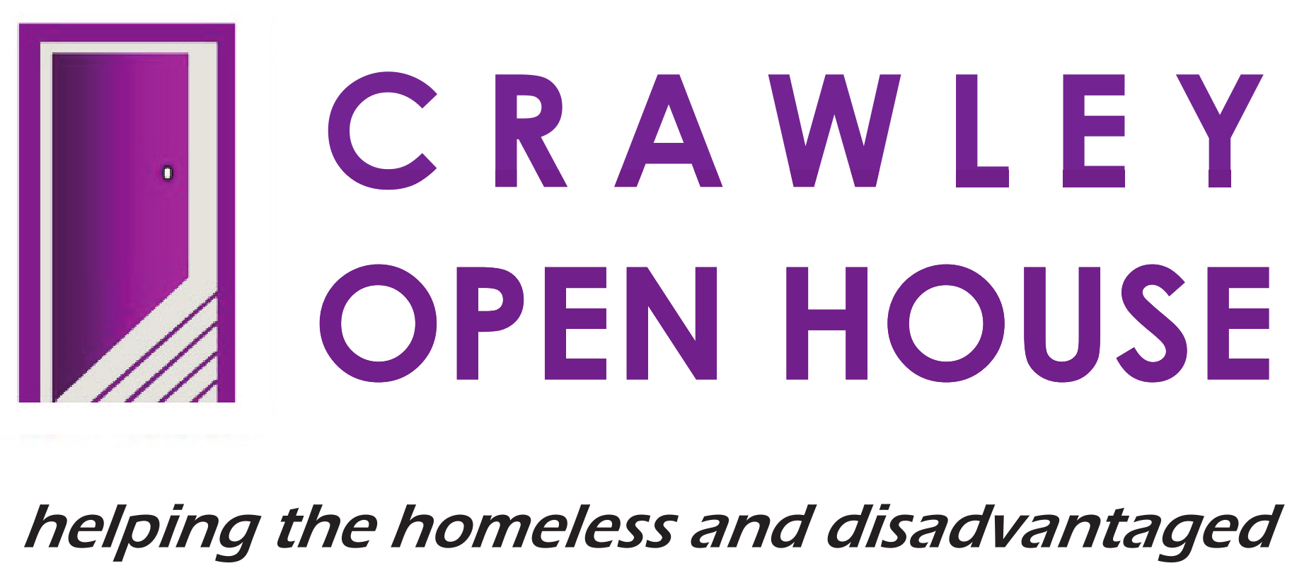 |  | PERSON SPECIFICATION –  RESOURCE-CENTRE HEALTH WORKER

CRITERIA TO BE EVIDENCED

QUALIFICATIONS

DESIRABLE:
- A relevant qualification in mental health, social work, health care, substance or alcohol dependency, etc.

EXPERIENCE

ESSENTIAL:
- Demonstrable experience of working in a setting providing health support, i.e., mental health, substance misuse, general and physical health, smoking cessation, etc.

- Demonstrable experience of working in a setting providing support and guidance to homeless or vulnerable people.

DESIRABLE:
3. Experience of ‘one to one’ support work, e.g., giving advice, key-working, risk assessment, etc.

- Experience of handling confidential information.

- Ability to initiate and maintain constructive relationships with clients, colleagues and other professionals from a variety of cultural/social backgrounds.

KNOWLEDGE AND UNDERSTANDING

ESSENTIAL:
- An understanding of mental health, drug and alcohol, physical health and other health issues including their cause, treatment and relevance to homeless and vulnerable adults.

- Knowledge of the roles of external agencies, e.g., Addaction, Health Services, Social Services, Probation, Police, Council, etc., and how they can be accessed to support adults with health issues.

DESIRABLE:
- Experience of working with therapeutic approaches, e.g. brief intervention, behavioural models, etc.

- Knowledge of housing and support needs of homeless people.

- An understanding of housing and welfare benefits.

SKILLS AND ABILITIES

ESSENTIAL:
- Good literacy and numeracy skills.

- An ability to understand and implement professional personal and team boundaries.

- Excellent communication and influencing skills. (Verbal and written.)

- Good organisational and time management skills.

4. SKILLS AND ABILITIES
DESIRABLE:
- An ability to implement strategies for coping with aggression and minimising risk.
2. Good IT skills.

5. PERSONAL QUALITIES
ESSENTIAL:
- A commitment to the practical application of the Crawley Open House Equal Opportunities Policy.

- Able to deal with an opposing point of view, exercising tact, sensitivity and diplomacy and the ability to listen to others.
- A commitment to developing and maintaining a high level of service to colleagues, clients and professional partners.
- A positive, self-motivated and enthusiastic attitude to work.
- Desire and willingness to make a positive contribution to a team.
- The capacity to handle pressure; to be adaptable to changing or conflicting demands and the ability to organise workload efficiently, balancing face-to-face work with paperwork.
- The ability to identify solutions and implement them.
- The ability to actively contribute and listen to ideas and suggestions that improve the quality of service.
- To have a positive attitude to training and professional development.

