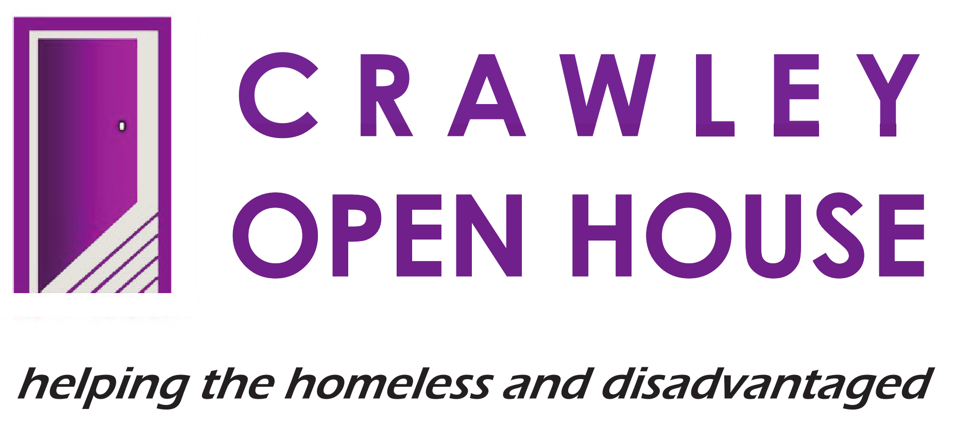 |  | JOB DESCRIPTION –  HOSTEL RESETTLEMENT WORKER

POST: | Hostel Resettlement Worker
RESPONSIBLE TO: | Head of Residential Services
LOCATION: | Riverside House, Crawley
HOURS: | Full-time – 40 hours per week.
ANNUAL LEAVE: | 200 hours per calendar year.
SALARY: | ££26,000

JOB PURPOSE

- To work as part of a team providing a comprehensive and integral resettlement programme.

- To provide and develop individual resettlement action plans for Riverside House residents.

- To contribute to a culture of excellence that puts our core values – caring, honesty, respect and responsibility – at the centre of all we do, whilst continually improving and developing our service.

MAIN DUTIES AND RESPONSIBILITIES

- SERVICE DELIVERY

- To liaise closely with colleagues to provide and develop individual resettlement plans for hostel residents.

- To carry out assessments of individual clients with the support of key-workers, advice workers and other specialist staff in order to identify the most appropriate resettlement option available.

- To liaise closely with colleagues in preparing clients on an individual basis for independent living, by providing practical advice and, where appropriate, emotional support. This may include viewing offers of accommodation and assisting clients with any negotiations, regarding suitability of offers, repairs, tenancy start date, removals, furniture and decoration, etc.

- To liaise with the appropriate agencies, e.g., Benefit Agency, Housing Benefit Officers, Housing Associations and Local Authorities, etc., on behalf of clients.

- To visit clients who have been resettled into independent housing, the move –on house and ensure that they continue to receive practical advice and emotional support.

- To research, visit and secure existing and new housing resources and move-on accommodation and maintain an up-to-date index of these.

- To carry out a weekly late shift on the rota as well as if required, life-skills sessions with clients.

- To advocate for client’s entitlements, challenging inequalities and exclusions.

- To promote client involvement in the delivery of the service through listening to their issues, involving them in user meetings, accepting constructive feedback, etc.

- ORGANISATIONAL RESPONSIBILITIES

- To maintain accurate, comprehensive and up-to-date records of all resettlement work with clients.

- To complete monitoring and statistical reports as required by the Head of Residential Services

- To maintain an up-to-date accommodation database.

- HEALTH AND SAFETY

- Ensure that you are aware of and comply with Crawley Open House Health and Safety Policies.

- Ensure that all residents are aware of the procedures, especially those relating to fire or other emergencies.

- To be aware of specific health and safety problems, relating to visits made to client’s own accommodation.

- EQUAL OPPORTUNITIES

- To ensure that Crawley Open House’s Equal Opportunities Policies are implemented and adhered to and to be particularly aware of the policies as they relate to a vulnerable client group.

- To challenge and report any incidences of prejudice, discrimination, oppression or behaviour that might be construed as abusive or poor practice.

- RELEVANT MATTERS

- To maintain confidentiality regarding clients, staff and business sensitive information in line with Crawley Open House policy and procedure.

- To undertake and participate constructively in induction, supervision, appraisal, meetings and relevant training.

- To contribute positively to good team relationships and the continuous improvement of services.

- To assist, when necessary, in the day centre by manning reception desk, helping in the kitchen, or assuming other duties, as required by any senior staff member.

THIS JOB DESCRIPTION OUTLINES THE MAIN DUTIES AND RESPONSIBILITIES OF THE POST HOLDER. THE POST WILL INCLUDE OTHER DUTIES AND RESPONSIBILITIES NOT SPECIFIED HERE.

